TV Tracker

**$4.99 – Standard Version**

SL Company is a Markham based tech business of one: Sam Leung. Our (my) mission is to bring a little more organization into peoples’ lives, be it teenagers or adults. Through our (my) creative and practical techniques, everyone can get something out of our (my) products.

We (I) have brought to you an innovative new project to benefit all binge watchers, procrastinators, and overly invested fans alike. TV TRACKERTM will finally help you keep track of your numerous dramas, sci-fi’s, and never again will you miss that iconic moment between your OTP. Never again will your best friend spoil the cliff-hanger from that episode you missed last night.

Key Features

*Unlimited users on one device!*

As long as every independent user has their own data in separate text files, you can virtually purchase one TV TRACKERTM for your whole household. Even better, you can have multiple windows open for separate users at the same time by using the File option (but be sure you trust the other users!).

*Password protected!*

When you open the program, an immediate prompt for a password will pop up, and if you select the correct text file, you get your own personal scheduling options.

*Add & Remove shows with ease!*

Without going through the hassle of adding a new show or removing one by following the text formatting in the text file, easily use the edit options to avoid the trouble.

*Sort & Filter all your shows!*

In the All Shows window, you can sort by show, year, day, timeslot, or genre. You also have the liberty of filtering out certain genres of shows (only one at a time), and if you want to filter year/day, you can just use the sorting sidebar and look for it in the table.

*Pick & Choose!*

Everyone gets a little busy sometimes, and when that happens, you might not have time to watch two 8:00 pm shows and your 9:00 pm. In such cases, we offer a Manage Today window, where you can conveniently cancel some shows for the day. As an additional feature, you can also use the I’m Feeling Lucky and create a random schedule for the day (note: we support simultaneous show watching).

*Weekly Layout!*

Want to plan out the rest of your week to revolve around your shows? No problem! In the Weekly Schedule window, we include all of your shows at their corresponding days and times for you.

How to Use

Your Data

There is no easy way to initiate the program except to write out all of your data in the following format:

*Username*

*Password*

*Today (Thursday)*

*Name of Show (Riverdale), Year (2017), Day of Week (Thursday), Time (8:00 pm), Genre (SciFi)*

*…*

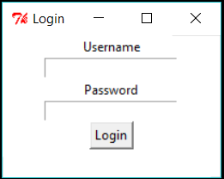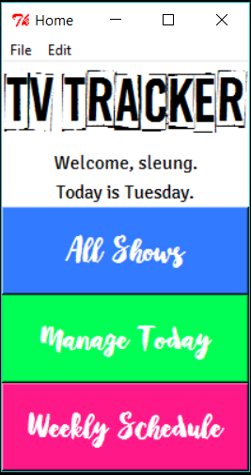Login

To begin scheduling your shows, you first must login with your personal username and password that you created in your text file. Be sure to click the right file (.txt) once you click the Login button.

Home

The Main/Home window acts as a navigation for all the features in the program. When using any option from the menu bar, it is best to use it only from the Home window with nothing else open if you want to close all the old windows before your changes. You have 3 main options in the Home: All Shows, Manage Today, and Weekly Schedule. These buttons will to access unique features personalized to your data.

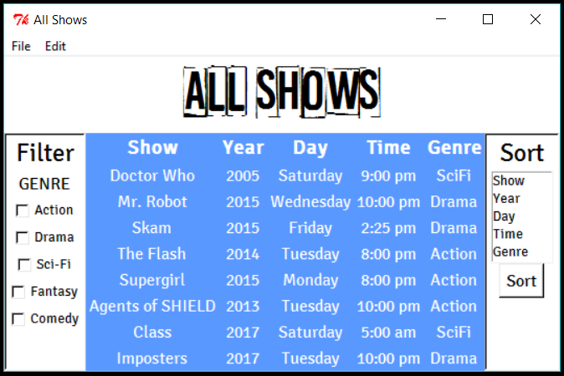All Shows

The All Shows button lists your shows the way you did them in your text file, by default. The filter sidebar on the left allows the option of filtering by the five built-in genres: Action, Drama, Fantasy, Comedy, and SciFi. The program allows additional genres into the list but you cannot use their genres as filters. The sort sidebar on the right has five options as well: Show, Year, Day, Time, and Genre. Click any one of these and then click Sort underneath the listbox. All filters will erase when you sort, but you can sort then filter.

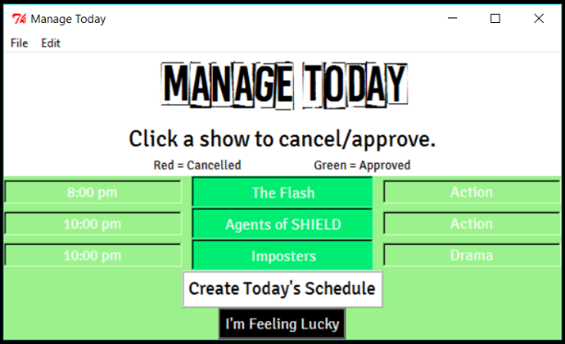Manage Today

This window will automatically take into today’s day from your text file (which you can change in Edit > Change Today) and allow you to make your own custom schedule for the day based on the shows you watch. If you’re completely free and don’t want to go to the trouble of picking, let chance decide with the I’m Feeling Lucky button, placed right below the Create Today’s Schedule button.

Weekly Schedule

The Weekly Schedule window is quite self explanatory in that it gives you an overview of the week’s schedule regarding your TV show watching. To allow for multiple shows in the same day and timeslot, there could be multiple lines of the same timeslot, depending on your shows. There’s nothing special to press here.

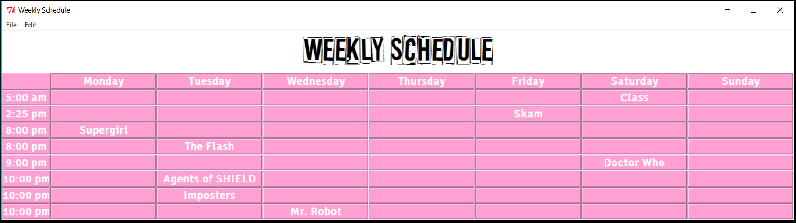

Menu

The full list of options:

File – Open, Close All Windows

The Open option opens up a new login page, allowing another user to access their data while keeping yours open. The Close All Windows option closes all the windows of the program.

Edit – Change Username, Change Password, Add Show, Remove Show, Change Today

The Change Username option opens a new window where you can enter in a new username and the program automatically opens a new Home window with your new username. The Change Password option opens a new window where you can enter in a new password and the program automatically opens a new login window to confirm your new password. The Add Show Option opens a window where you can enter in a new show with a name, year, day, time, and genre. The year must be a positive number and the timeslot must have the 12-hour clock format (ie. 9:00 pm). All existing genres are supported by this program but only Action, Drama, SciFi, Fantasy, and Comedy are in the filter section for the All Shows window. The Remove Show option has the same format as Add Show, and remember to enter in the show information exactly as it is entered into the system. The Change Today option lets you manually change the day of the week so Manage Today works properly.

Help – Instructions

The instructions are a summary of the How To Use section of this user guide. The window will direct you to the terminal which will have the instructions above.

*Note:*

*When you are done with any given window, close it to ensure that you keep an organized view of your shows.*